# Hello Embedded World!

This short demo program represents “Hello World!” in an embedded environment by blinking an LED.

You will need the following to complete this exercise

* Atmel Studio 7.0
* AVRDUDE
* Arduino UNO R3
* Breadboard
* LED
* 330ohm Resistor
* Wires
* USB Power Supply (non-computer USB slot) – Recommended

Begin by following the directions to setup Atmel Studio 7.0, AVRDUDE, and a New Project.

Now enter the following code into your ASM file:

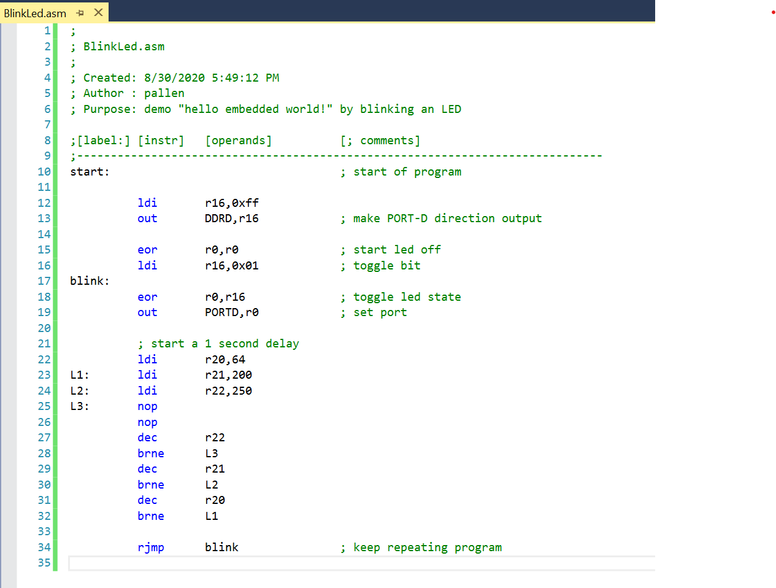

The instructions for this demo will be explained as we cover them throughout the semester.

Build the Program

* Menu: Build <project name>

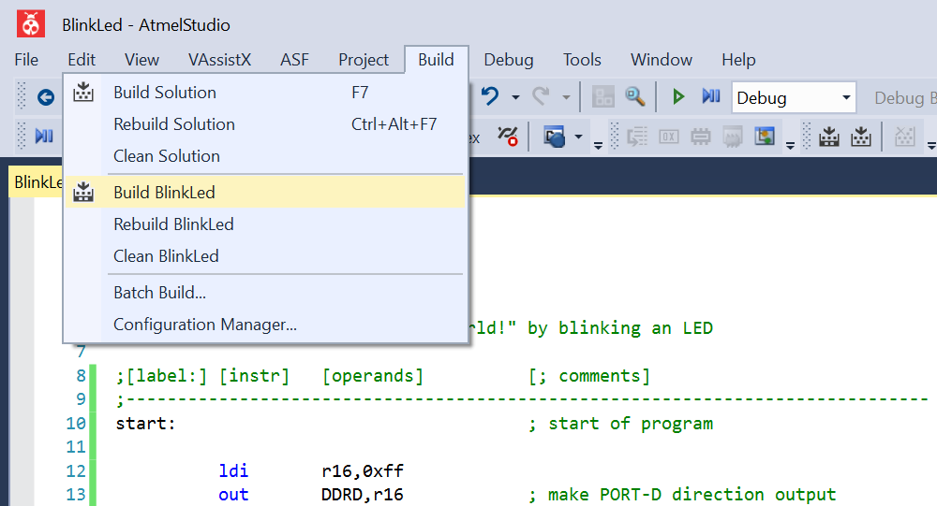

* Review Output from the Build

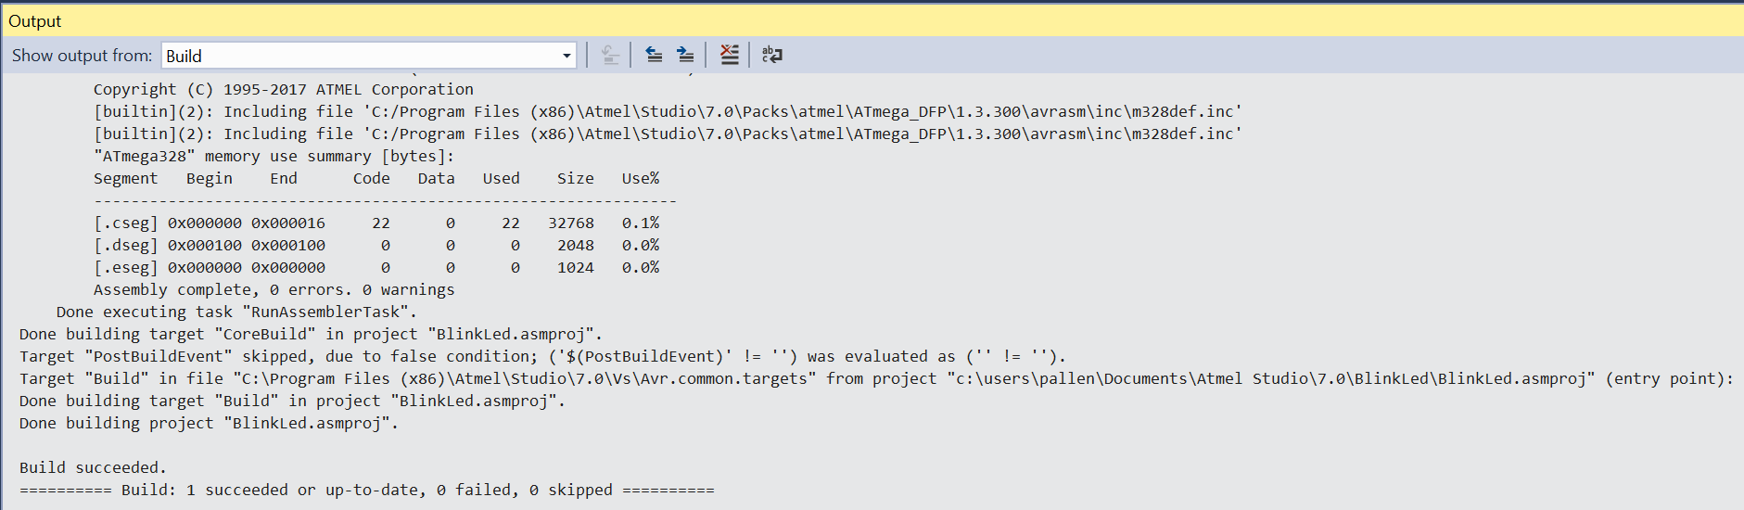

* + We want to see “Build succeeded”
  + Build errors will be displayed somewhere above if the build fails

Program the Arduino

* Connect your Ardunio into a USB port on your computer
* Program using Menu: Tools\Arduino Programmer

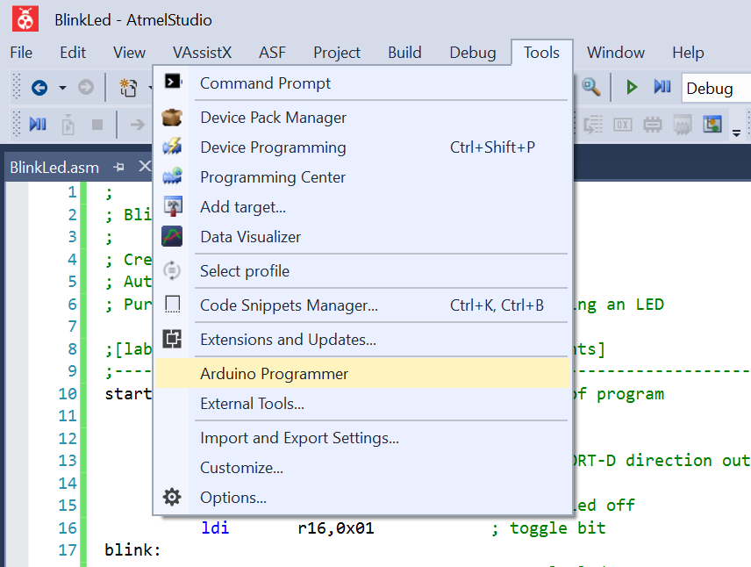

* Output window should indicate successful programming

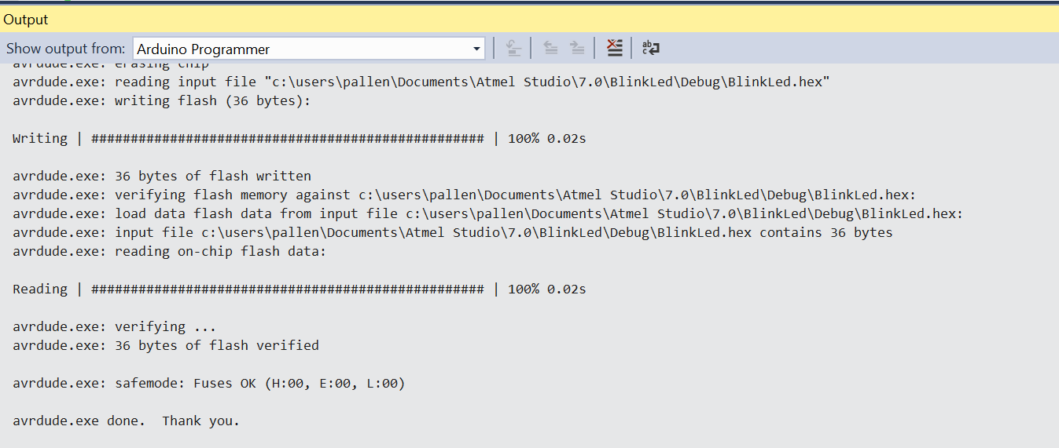

* Disconnect your Arduino from your computer

Build LED Circuit

* Start with a breadboard
* Place an LED with long leg (anode) in one of the power rails (red +) and short leg (cathode) in a row of the breadboard (mine is in row #10)
* Place one end of 330ohm resistor in ground rail (black -) and other leg in row with LED (row #10 in mine)
* Connect one wire (red in mine) to the positive power rail, and one wire (black in mine) to the negative ground rail of the breadboard

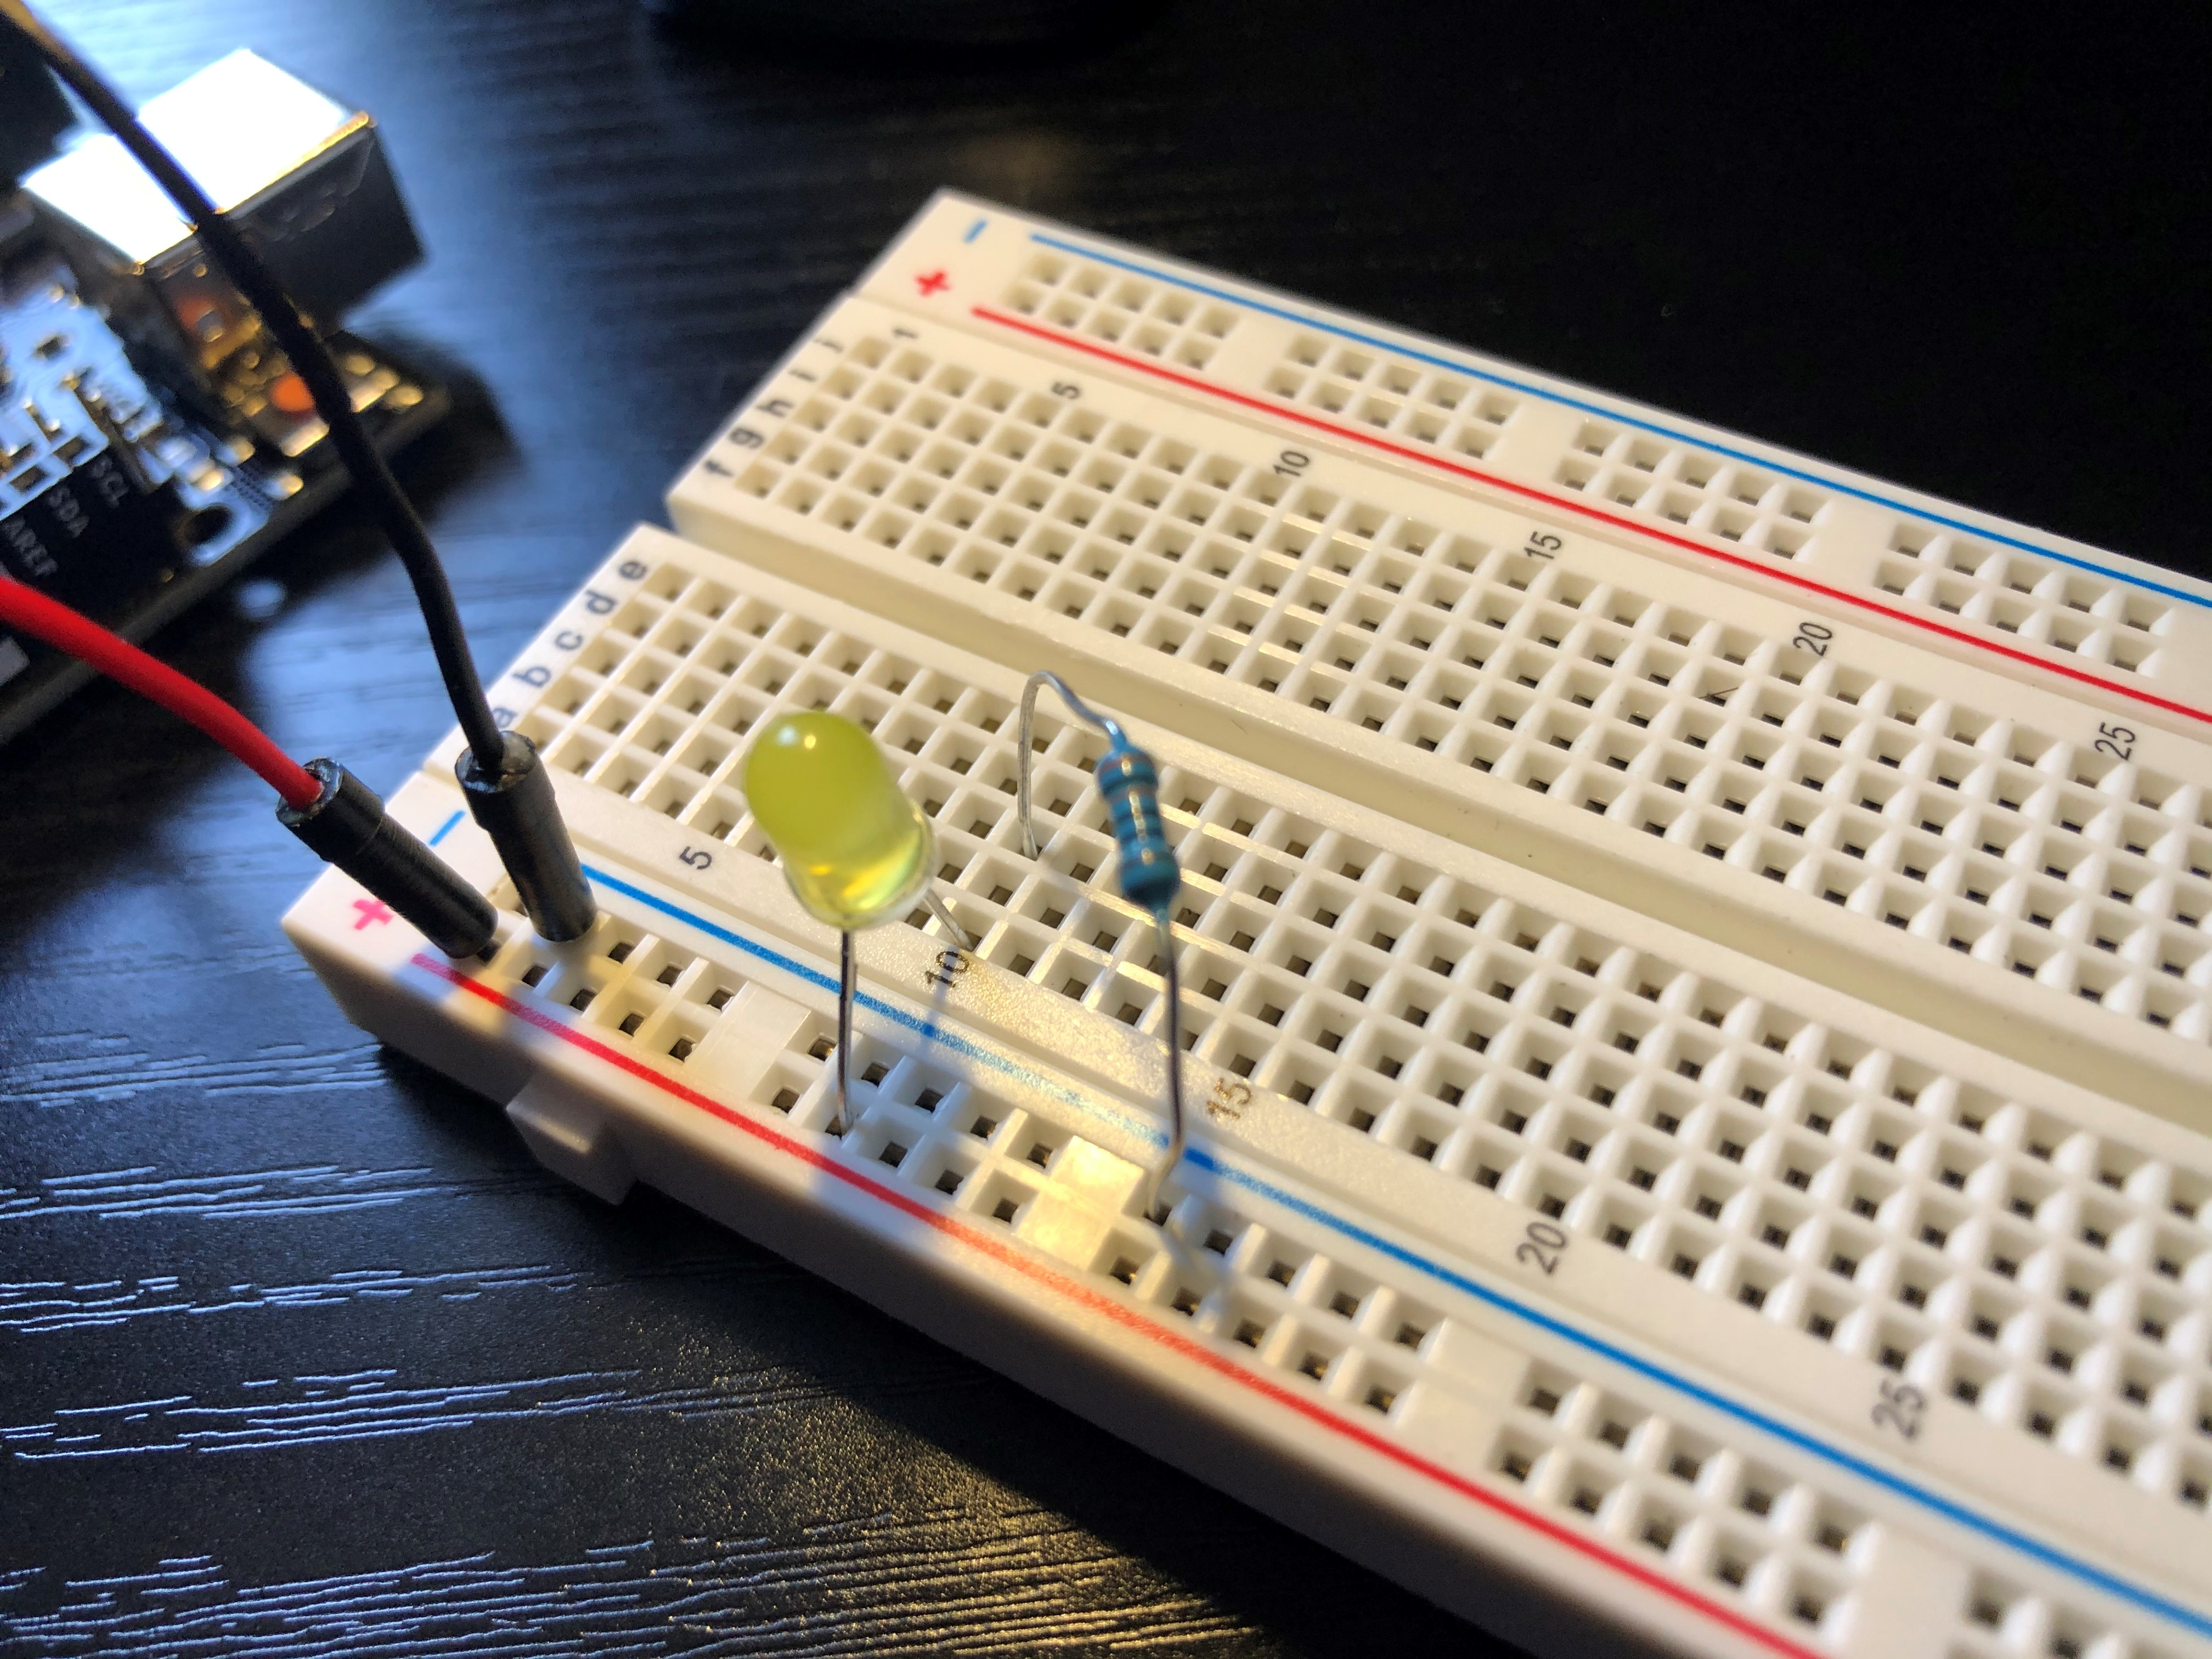

|  |  |
| --- | --- |
| LED  Symbols:Pleasing Nodery Diode Anode Ledlabel Marking Vs Cathode On Led 90  Amp And To Case Symbol Definition Chatode Identification Wiki P Type P… |  Diode, Led, Case | 330-ohm Resistor  Shop 50 pcs Metal Film Resistors 330 Ohm 0.5W 1/2W 1% Tolerances 5 Color  Bands - On Sale - Overstock - 26404788 |

Connect Arduino to the Circuit

* Make sure power is not applied to the Arduino (i.e. disconnect the Arduino from the computer)
* Place the wire coming from the positive rail of the breadboard (red wire in my circuit) into the Port-D Pin-0 (labeled 0->RX)
* Place the wire coming from the negative rail of the breadboard (black wire in my circuit) into a ground of the Arduino (labeled GND)

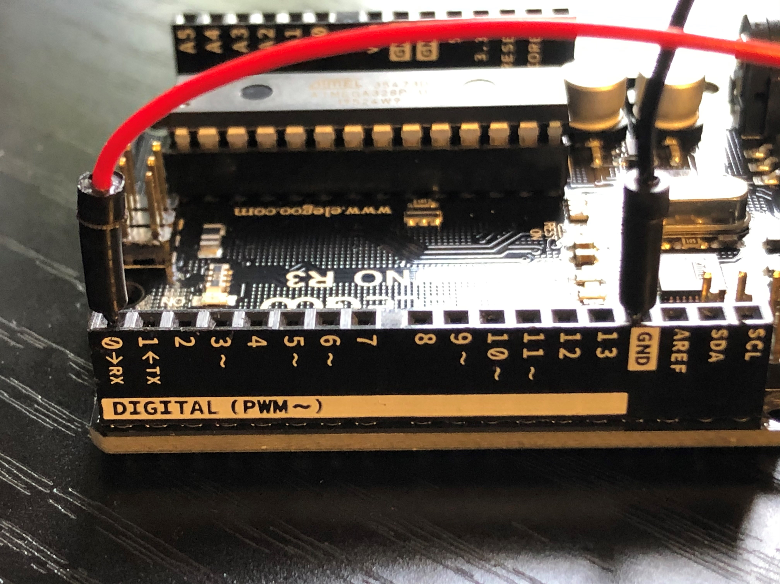

Apply Power to the Arduino

* Apply power to your Arduino – LED should blink on/off each second

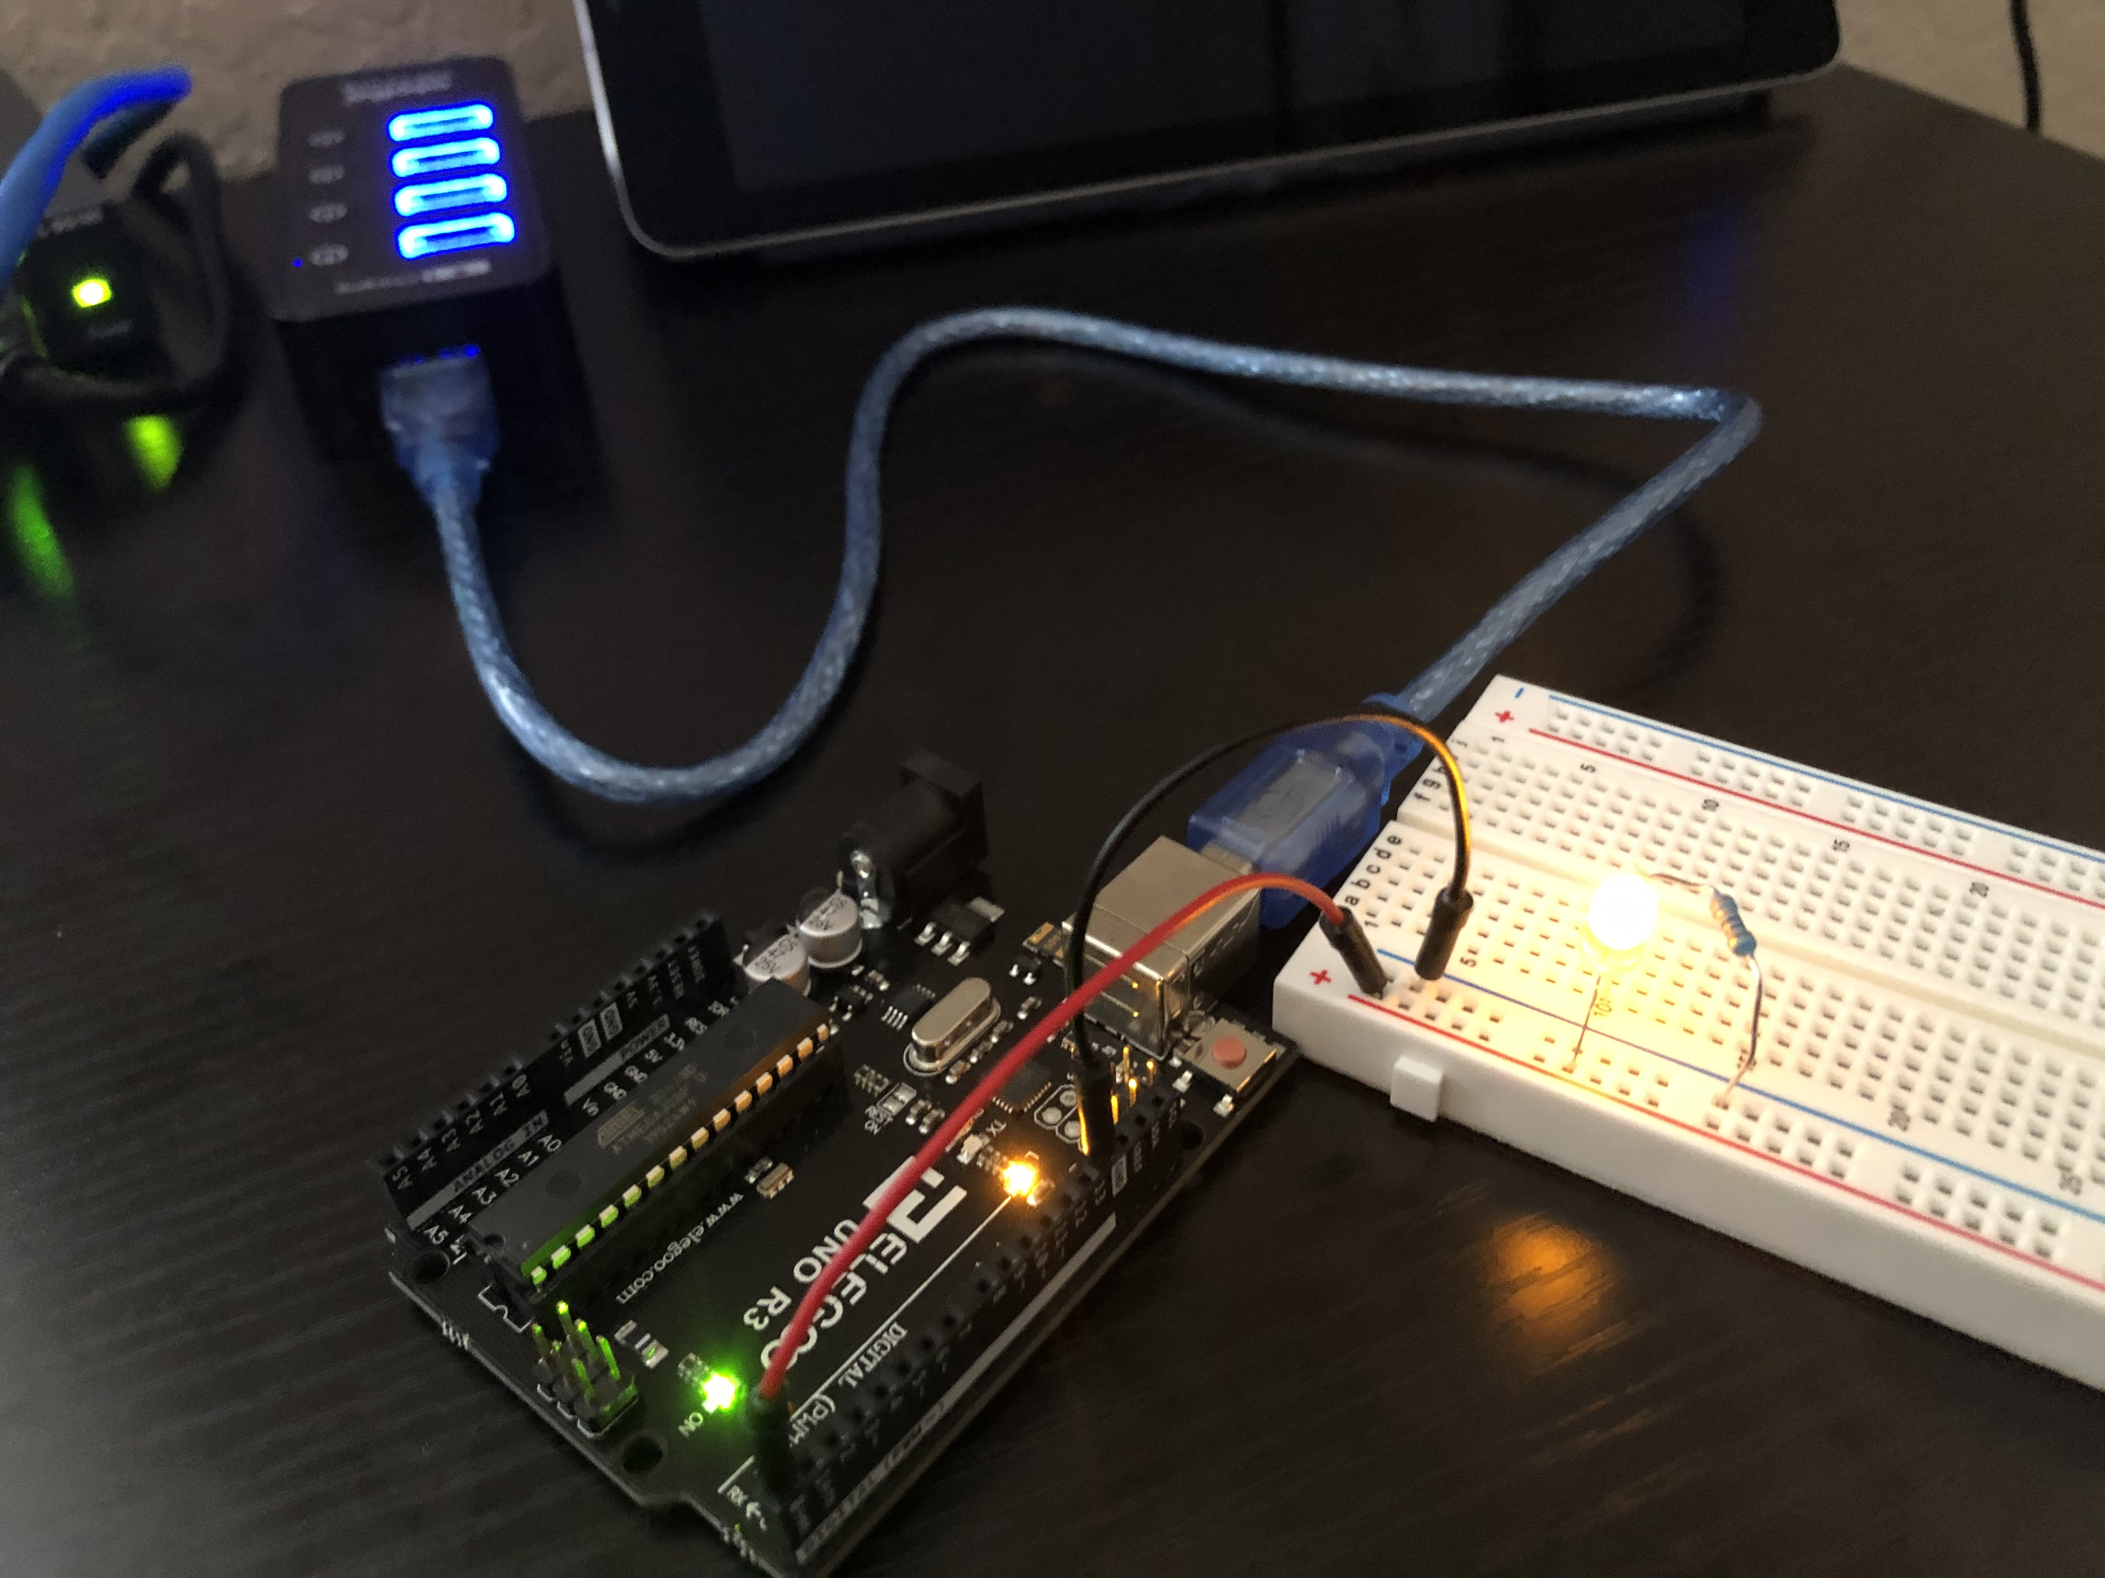

If possible, connect your Arduino to a non-computer USB power supply, i.e. mine is connected to a charging port on my USB hub. This helps prove to yourself that you programmed your MCU successfully, i.e. the program is running from your Arduino, not your computer.